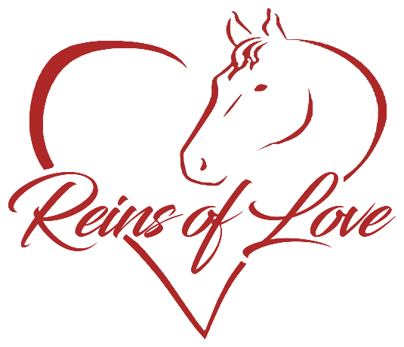

Volunteer Application
Reins of Love takes great pride in our care for our clients and our animals. We aspire to make a difference in our local community, sharing all we have.
We enjoy sharing bonds with both human and equine and helping all achieve dreams and goals.

Please fill in completely if something does not apply to you please put N/A in the space.
Full Name (First,Middle Initial, Last)______________________
Date of Birth_______________
Address:_____________________________________________
City:_______________State:_________Zip Code:____________
Phone Number:__________________ Cell:__________________
email address:________________________________________

How many hours are you willing to or can you work?__________
Do you have limitations that keep you from doing certain things?_____
Do you have Transportation available?________________

The next questions are to learn what your interests are and help us provide you with a match to our needs.
What experience do you have? (you can chose more than one.)
[] No Experience [] Fundraising [] Grants [] Event Planning
[] Animal Handling [] Safety [] Animal Care [] Transport Animals [] Animal Health [] Veterinarian Care [] Answer Phones [] Retail [] Business
[] Animal Behavior [] Customer Service [] Media [] Community Service Programs [] Other___________________________

Which of the following types of animals do you have experience with?
You can chose more than one.
[] Dogs [] Cats [] Birds [] Horses [] Cows [] Sheep
[] Donkey/Mules [] Other________________

Do you have specific experience with a particular Breed(s) if so What Breed(s)?_________________________________________________________________________________________________

Sometimes we have emergencies that we need to come together and handle. Would you be able to be called at a moments notice to help?
______ If so what kinds of emergencies would you be able to be called on to help us?
[] Disaster (storms, fire, etc) [] Veterinarian Emergency(animal injured or sick and needs vet care and emergency) [] Medical Emergency ( pet hospitalized)
[] Other__________________

We do lots of events and always need volunteers to help. Which types of events would you or can you help with?

[] Birthday parties []Parades []Vendor Events []Clinics (Vaccination, Microchipping, etc) [] Fundraisers [] Media [] Photo
[] Fairs [] Educational []Meet and Greet []Other___________
[]None

List References :
1) Name________________________________
Address________________________________
Phone number___________________________

2)Name________________________________
Address________________________________
Phone number___________________________

3)Name ________________________________
Address________________________________
Phone Number___________________________

Please sign here ______________________________________
Date_________________

We reserve the right to check references and do background checks on our volunteers as we deem necessary.

Thank you for your interest in volunteering with Reins of Love
Can submit by downloading and filling it out and scanning it back in and emailing it to us, by downloading it and printing it and filling it out and mailing it to us, drop it off in person and soon be able to fax as soon as our fax is up and running.
E-Mail – Marx.reinsoflove@gmail.com
Address – Reins of Love
1125 245th Ave Nw Isanti, Mn 55040

