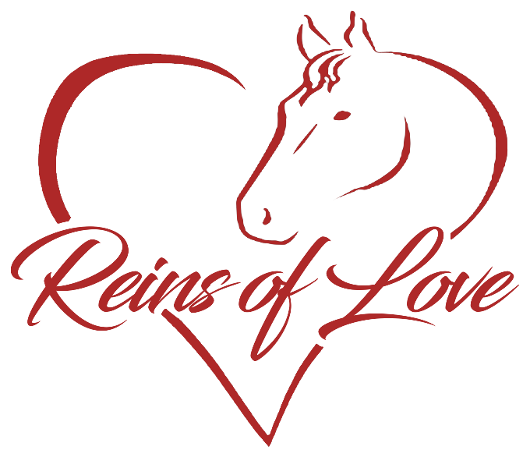
RELEASE OF LIABILITY
READ CAREFULLY - THIS AFFECTS YOUR LEGAL RIGHTS
In exchange for participation in the activity of Horseback riding and/or equine therapies organized by Reins of Love, of 1125 245th Ave NW, Isanti, Minnesota, 55040 and/or use of the property, facilities, and services of Reins of Love, I agree for myself and (if applicable) for the members of my family, to the following:

1. AGREEMENT TO FOLLOW DIRECTIONS. I agree to observe and obey all posted rules and warnings, and further agree to follow any oral instructions or directions given by Reins of Love, or the employees, representatives, or agents of Reins of Love.

2. ASSUMPTION OF THE RISKS AND RELEASE. I recognize that there are certain inherent risks associated with the above described activity and I assume full responsibility for personal injury to myself and (if applicable) my family members, and further release and discharge Reins of Love for injury, loss or damage arising out of my or my family's use of or presence upon the facilities of Reins of Love, whether caused by the fault of myself, my family, Reins of Love or other third parties.

3. INDEMNIFICATION. I agree to indemnify and defend Reins of Love against all claims, causes of action, damages, judgments, costs, or expenses, including attorney fees and other litigation costs, which may in any way arise from my or my family's use of or presence upon the facilities of Reins of Love.

4. FEES. I agree to pay for all damages to the facilities of Reins of Love caused by any negligent, reckless, or willful actions by me or my family.

5. CONSENT. I, the Guardian, __________________________________, consent to the participation of _________________, in the activity of Horseback riding and/or equine therapies, and agree on behalf of the above minor to all of the terms and conditions of this Agreement. By signing this Release of Liability, I represent that I have legal authority over child/and/or am 18yrs of age.

6. MEDICAL AUTHORIZATION. In the event of an injury to the above minor during the above-described activities, I give my permission to Reins of Love or to the employees, representatives or agents of Reins of Love to arrange for all necessary medical treatment for which I shall be financially responsible. This temporary authority will begin on ________, 202_ and will remain in effect until terminated in writing by the undersigned or (date)_____________ 202_, whichever occurs first. Reins of Love shall have the following powers:

a. The power to seek appropriate medical treatment or attention on behalf of my child as may be required by the circumstances, including without limitation, that of a licensed medical physician and/or a hospital.
b. The power to authorize medical treatment or medical procedures in an emergency.
c. The power to make appropriate decisions regarding clothing, bodily nourishment, and shelter.

7. APPLICABLE LAW. Any legal or equitable claim that may arise from participation in the above shall be resolved under Minnesota law.

8. NO DURESS. I agree and acknowledge that I am under no pressure or duress to sign this Agreement and that I have been given a reasonable opportunity to review it before signing. I further agree and acknowledge that I am free to have my own legal counsel review this Agreement if I so desire. I further agree and acknowledge that Reins of Love has offered to refund any fees I have paid to use its facilities if I choose not to sign this Agreement.

9. ARM'S LENGTH AGREEMENT. This Agreement and each of its terms are the product of an arm's length negotiation between the Parties. In the event any ambiguity is found to exist in the interpretation of this Agreement, or any of its provisions, the Parties, and each of them, explicitly reject the application of any legal or equitable rule of interpretation which would lead to a construction either "for" or "against" a particular party based upon their status as the drafter of a specific term, language, or provision giving rise to such ambiguity.

10. ENFORCEABILITY. The invalidity or unenforceability of any provision of this Agreement, whether standing alone or as applied to a particular occurrence or circumstance, shall not affect the validity or enforceability of any other provision of this Agreement or of any other applications of such provision and such invalid or unenforceable provision shall be deemed not to be a part of this Agreement.

11. EMERGENCY CONTACT. In case of an emergency, please call _________________ (Relationship: _________________) at _________________ (Day), or _________________ (Evening).

I HAVE READ THIS DOCUMENT AND UNDERSTAND IT. I FURTHER UNDERSTAND THAT BY SIGNING THIS RELEASE, I VOLUNTARILY SURRENDER CERTAIN LEGAL RIGHTS.

I understand & agree this is a legal representation of my signature.
Make this official by signing:

______________________________________________________ Date______________

Billing Name______________________________________Rider____________________________
Address__________________________________________
_________________________________________________

Contact #_______________________________________

Alternate number________________________________ Email_____________________

